Git

Creating a new respository,

use the two repository commands and still fatal

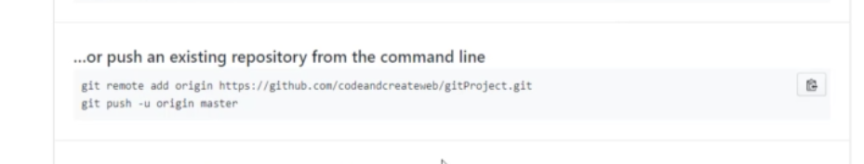

use git push origin master

